- The Monetary Policy Committee voted to lower Bank Rate by 25bps to 5% at its meeting this week. The MPC's new forecast suggests further rate cuts are on the cards, but the committee was at pains to emphasise that it will take a cautious approach to loosening policy. So we expect Bank Rate to remain at 5% in September, before another 25bps cut at the November meeting.
- The Chancellor's review of the new government's fiscal inheritance pointed to a £22bn departmental overspend this year, much of which will persist. We view this announcement as the Chancellor building a case for further tax rises beyond those set out in Labour's manifesto.
With the Monetary Policy Committee's August meeting and the publication of the Treasury's review into the new government's fiscal inheritance, this week shed light on how the near-term outlook for monetary and fiscal policy will play out.
The MPC voted 5-4 to lower Bank Rate by 25bps to 5%. The minutes highlighted that the committee remains deeply divided, with the narrow vote split coming about as Governor Andrew Bailey, Clare Lombardelli, and Sarah Breeden joined the two committee members who had voted for a cut at the previous two meetings, to kick-off the Bank of England's rate-cutting cycle.
Those who voted to cut continued to preach the more forward-looking approach that was introduced in June's minutes, signalling that they now feel more confident in their understanding of the drivers of inflation, so can reduce their reliance on backward-looking indicators of inflation persistence. This group argued that much of the recent upside surprises in services inflation had been driven by movements in volatile components and April's larger-than-expected uprating of index-linked contracts and regulated prices. Stripping out these factors, which are less relevant for future inflation, showed there had been "some progress in moderating risks of inflation persistence" (Chart 1). Furthermore, forward-looking survey data, such as the BoE's Decision Maker Panel, pointed to weaker wage and price pressures over the next year.
Chart 1: Excluding the annual uprating and volatile categories, services inflation has been broadly stable
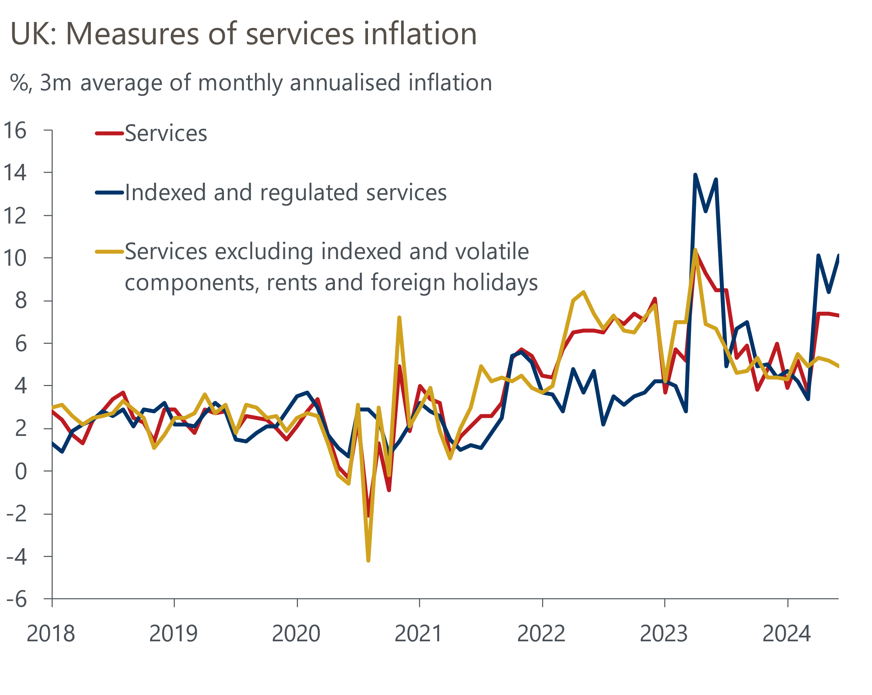
Source: Bank of England Monetary Policy Report

In contrast, the four committee members who voted to keep Bank Rate on hold argued that while external factors had played a major role in reducing headline inflation, underlying domestic inflationary pressures appeared more entrenched. Therefore, they preferred to "maintain the current level of Bank Rate until there was stronger evidence that these upside pressures would not materialise".
The MPC's new forecast was based on market interest rate expectations that showed 100bps of additional rate cuts by the end of 2025. The MPC projected that CPI inflation will undershoot the 2% target at the two- and three-year horizons, suggesting markets are underestimating the likely scale of rate cuts (Chart 2).
Chart 2: The latest forecast sees inflation undershooting the 2% target at the policy horizon
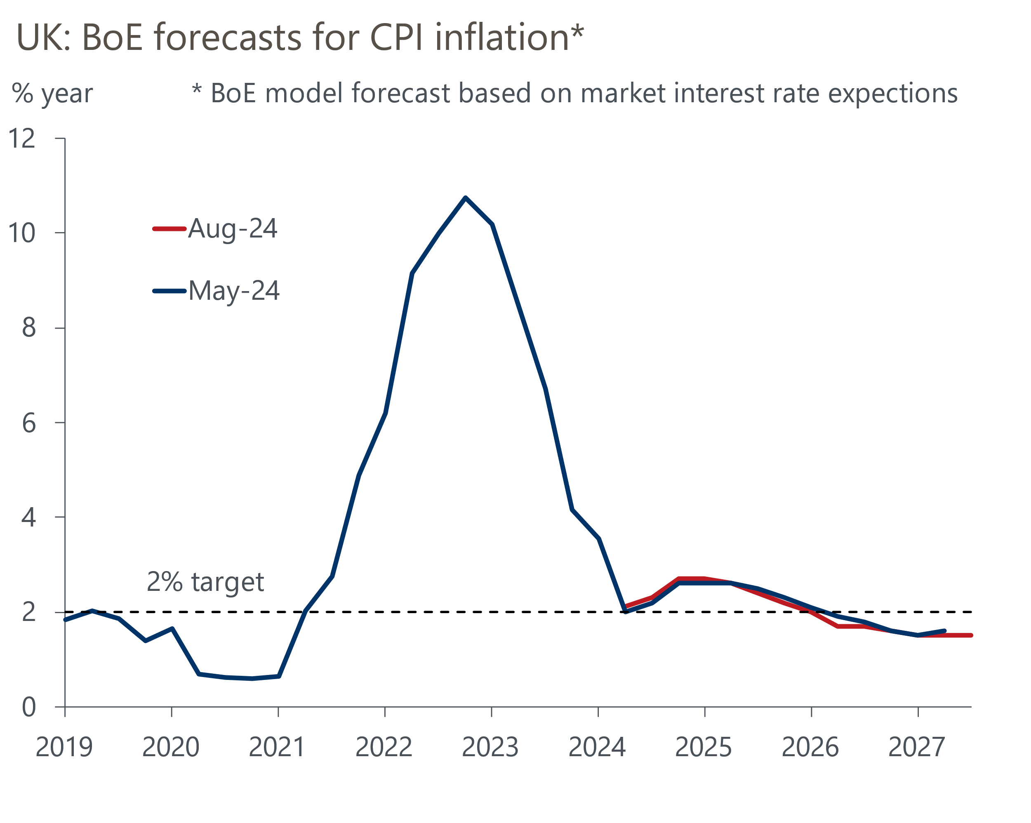
Source: Bank of England Monetary Policy Report
But while the MPC's new forecast points to further rate cuts, the committee's core message was that the pace of loosening would be gradual. Indeed, in his opening remarks, Governor Bailey said: "We need to put the period of high inflation firmly behind us and we need to be careful not to cut rates too much or too quickly". The MPC also emphasised the uncertainty around the outlook for inflation and Bank Rate by publishing a mean forecast that showed inflation closer to the 2% target in the medium-term, which shows that the committee views the risks to inflation as being skewed to the upside.
The minutes also suggested that for some who voted to lower Bank Rate, the decision was "finely balanced". Given this, and the MPC's collective caution that August's decision would not herald a rapid succession of rate cuts, we expect the MPC will keep Bank Rate at 5% in September. Further out, we maintain our forecast for another 25bps cut in November and 100bps of further loosening in 2025.
The week's other major event saw new Chancellor Rachel Reeves present the Treasury's audit of government spending plans. The analysis concluded that departmental spending in fiscal year 2024-2025 was likely to be around £22bn (0.8% of GDP) higher than the totals included in March's Budget. But the review's focus on the current fiscal year meant it ignored several additional medium-term cost pressures. Spending plans sketched out by the previous government for subsequent fiscal years already looked implausibly tight, and the higher starting point means the picture now looks even worse. The review also ignored other costs pressures, such as compensation payments to those affected by the infected blood scandal, the desire to increase defence spending, and the urgent need to increase prison capacity.
Reeves announced some small-scale cost-saving measures that will take effect immediately. But the main takeaway was that the Chancellor is building an argument for further tax rises in the Budget on October 30, above and beyond those set out in the Labour party's election manifesto.
We will incorporate the implications of the fiscal announcement into our August forecast, which will be released as part of our global update on August 8. The changes imply slightly higher public sector inflation and lower real activity growth. The net impact will be a modest downgrade to our forecasts for real GDP growth in 2025 and 2026.

The week ahead
A very quiet week of economic data is in prospect, with July's final S&P Global services survey the only release of note. The flash survey reported a stronger services PMI than in June, which was driven by an acceleration in new orders, following reports that some firms paused spending decisions prior to the general election. We see little reason to think July's final services PMI reading will shift significantly from the flash outturn. This would leave the final composite PMI at 52.7.
Table 1: Week ahead calendar
Date | Events | Period | Measure | Unit | Previous | Forecast
Aug 5 | S&P Global/CIPS services | Jul | PMI | % bal | 52.4 | 52.4
Aug 5 | S&P Global/CIPS composite | Jul | PMI | % bal | 52.7 | 52.7
Aug 6 | S&P Global/CIPS construction | Jul | PMI | % bal | 52.2 | 52.5
Aug 7 | Halifax house prices | Jul | m/m | % | -0.2 | 0.1
Aug 7 | Halifax house prices | Jul | y/y | % | 1.6 | 1.4
Source: Oxford Economics

Key forecasts
Table 2: UK forecast overview
(Annual percentage changes unless specified)
 | 2022 | 2023 | 2024 | 2025 | 2026 | 2027
GDP | 4.3 | 0.1 | 1.1 | 2.0 | 1.9 | 1.7
Private consumption | 4.8 | 0.2 | 0.8 | 2.4 | 2.2 | 1.6
Fixed investment | 8.0 | 2.2 | -0.1 | 1.3 | 2.7 | 2.1
Government consumption | 2.3 | 0.5 | 2.9 | 3.2 | 1.6 | 1.5
Exports of goods and services | 9.0 | -0.5 | -2.3 | 2.6 | 2.3 | 1.7
Imports of goods and services | 14.6 | -1.5 | -0.4 | 3.7 | 2.9 | 1.9
Industrial Production | -3.5 | -0.4 | -0.3 | 0.8 | 1.5 | 1.2
Consumer prices | 9.1 | 7.3 | 2.6 | 2.5 | 2.3 | 2.2
Unemployment rate (%) | 3.9 | 4.0 | 4.4 | 4.2 | 3.9 | 3.9
Current a/c balance (% of GDP) | -3.1 | -3.3 | -3.4 | -3.2 | -3.3 | -3.2
Government balance (% of GDP) | 4.4 | 5.0 | 3.7 | 3.2 | 2.3 | 1.5
Cen. bank policy rate (%, EOP) | 3.50 | 5.25 | 4.75 | 3.75 | 2.75 | 2.00
10yr govt. bond yield (%, EOP) | 3.67 | 3.54 | 4.00 | 3.67 | 3.19 | 2.85
Exchange rate (US$ per £, EOP) | 1.20 | 1.27 | 1.26 | 1.28 | 1.30 | 1.32
Exchange rate (euro per £, EOP) | 1.13 | 1.15 | 1.18 | 1.18 | 1.17 | 1.16
Source: Oxford Economics
Table 3: Quarterly forecasts for the UK
 | 2024 |  |  |  | 2025
 | Q1 | Q2 | Q3 | Q4 | Q1 | Q2 | Q3 | Q4
GDP (% year) | 0.3 | 0.8 | 1.2 | 2.1 | 1.9 | 1.9 | 2.1 | 2.2
CPI inflation (% year) | 3.5 | 2.1 | 2.1 | 2.6 | 2.5 | 2.4 | 2.6 | 2.4
Bank Rate (%, EOP) | 5.25 | 5.25 | 5.00 | 4.75 | 4.50 | 4.25 | 4.00 | 3.75
10yr gilt yield (%, EOP) | 3.95 | 4.17 | 4.05 | 4.00 | 3.92 | 3.85 | 3.76 | 3.67
US$ per £ (EOP) | 1.26 | 1.26 | 1.26 | 1.26 | 1.26 | 1.27 | 1.27 | 1.28
Euro per £ (EOP) | 1.17 | 1.18 | 1.18 | 1.18 | 1.18 | 1.18 | 1.18 | 1.18
Source: Oxford Economics

Latest Country Economic Forecast:
July 16, 2024

Recent publications

Data Insights
Manufacturing PMI rose to a two-year high in July
Elevated mortgage rates continued to weigh on approvals in June
Flash PMIs suggest the economy got off to a solid start in Q3
Noisy retail data masks gradual underlying improvement
Borrowing overshoot likely to continue through 2024-2025

Research Briefings
Rate-cut cycle kicks off but it’s unlikely to be sequential
Reeves review lays the ground for October tax rises
MPC preview – Markets hold the key to timing of rate cut
Labour's fiscal inheritance and the Reeves Review
MPC prepares the ground for an August rate cut

Contacts

Oxford Economics' UK team
- Andrew Goodwin - Chief UK Economist - agoodwin@oxfordeconomics.com
- Edward Allenby - UK Economist - eallenby@oxfordeconomics.com

